Contract Balance by Agency Report (WIS-SR-003)
Select Report Month/Year and Supplier Name
Click to open Webi Report
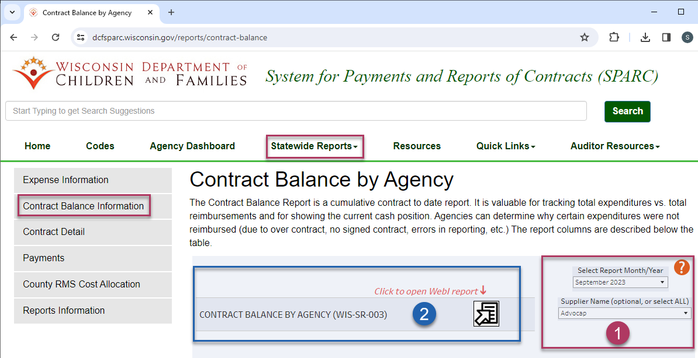

Click to open prompts:
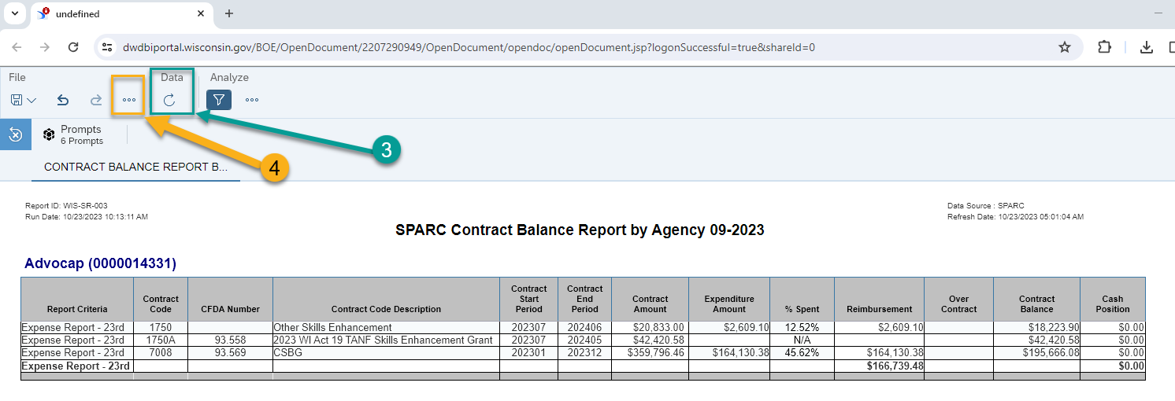
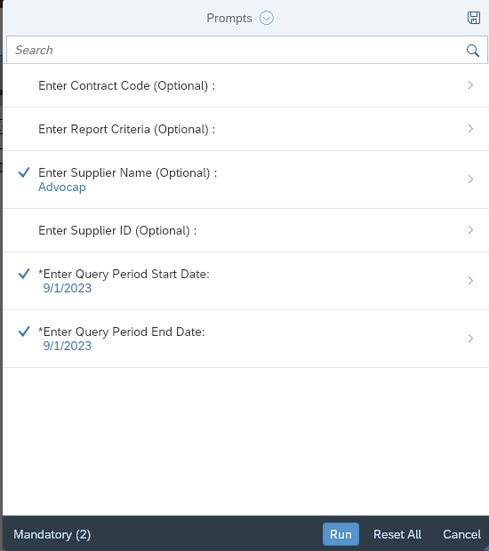

Click to export report:
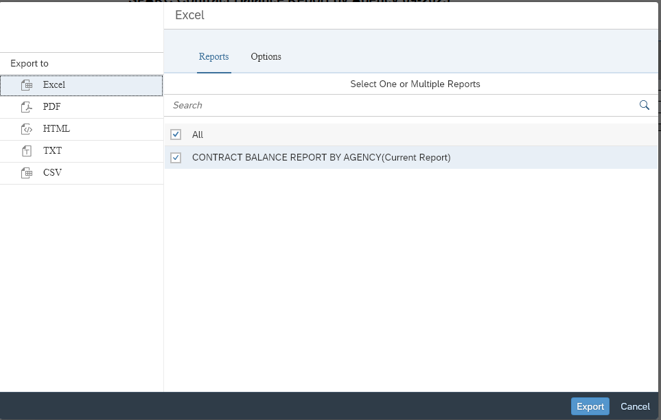

- Contract Start and End Period refers to the SPARC allocation period
  - i.e., if a contract is split into a Jan-June and July-Dec allocation in SPARC, only the July-Dec allocation will appear on the Sept report
- Cash Position – A positive amount is what is currently owed to the provider, a negative amount is what a provider currently owes DCF

Monthly Expenditure Year to Date Report (WIS-SR-011)
Select Report Month/Year and Supplier Name
Click to open Webi Report
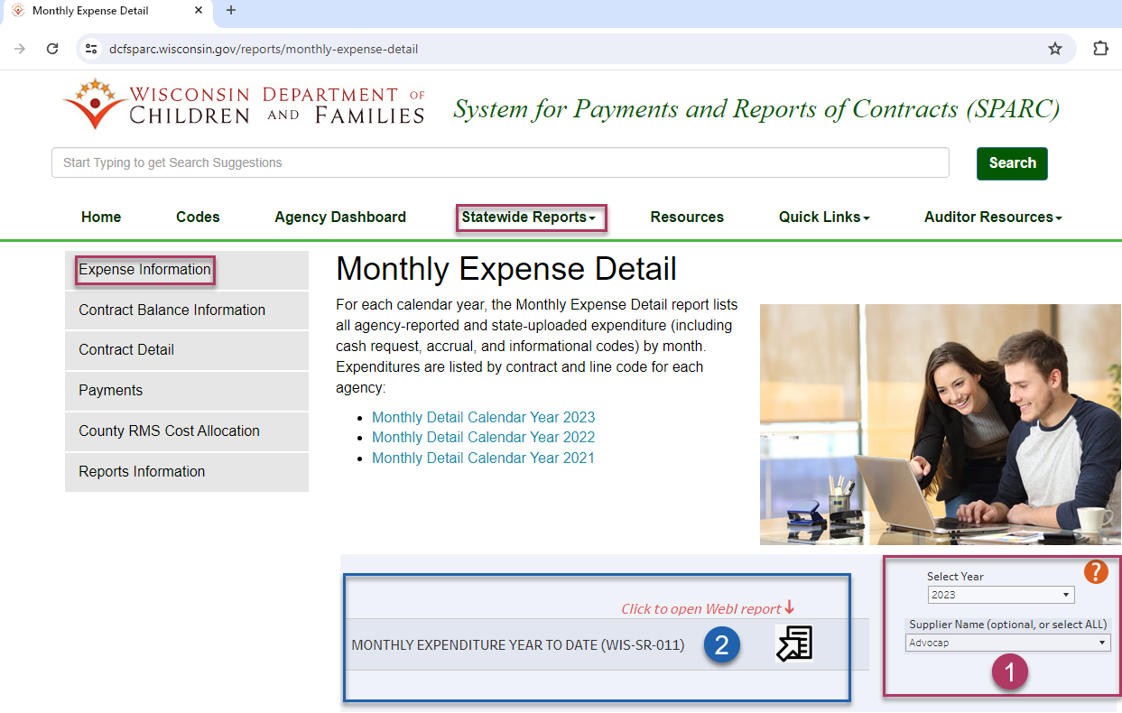
Click to open prompts:
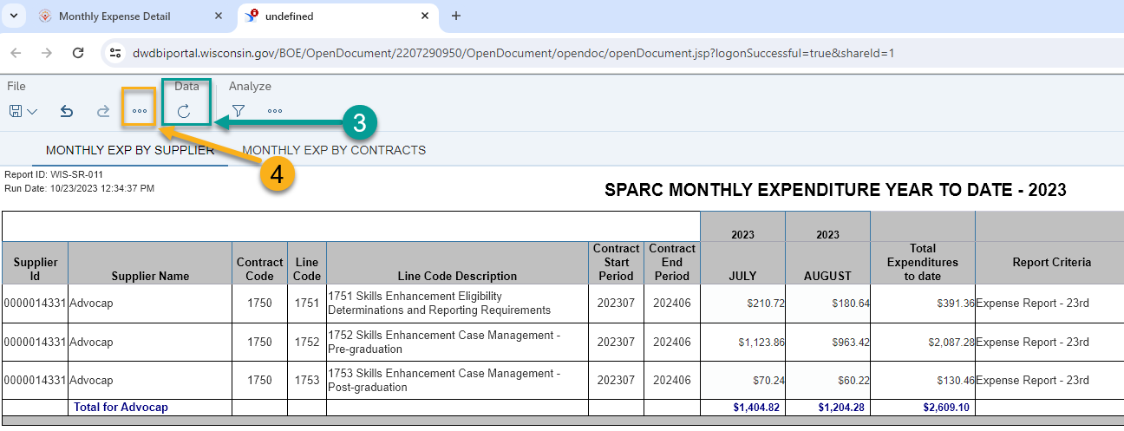
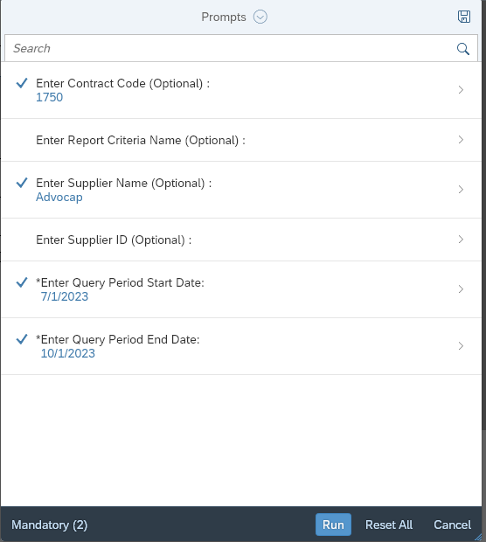
Click to export report:
